
LESSON NOTE | DETAILED EXPLANATORY NOTES
BIOENERGY
BIOELECTROCHEMICAL REACTOR & WATER TREATMENT

GRADE 12 - BIOLOGY
■ ■ ■

What is a Bioelectrochemical Reactor?
A bioelectrochemical reactor (BER) is a device in which living microbes (bacteria) break down organic matter and, in doing so, drive an electric current. The best-known type is the microbial fuel cell (MFC). What makes a BER special is that it does two useful jobs at once: it cleans dirty water by digesting the organic pollutants in it, and it generates electricity (or a clean fuel such as hydrogen) at the same time. It is a bio-battery that runs on wastewater.
This lesson explains how a bioelectrochemical reactor works, how the bacteria release electrons, how the reactor is used for water treatment, and its benefits, limitations and potential in Papua New Guinea.
Why Bioelectrochemical Reactors Matter
- They treat wastewater - removing organic pollutants.
- They generate electricity from the waste at the same time.
- They can produce hydrogen, a clean fuel.
- They turn a waste problem (sewage) into useful energy and clean water.
Bioelectrochemical Reactor / Water Treatment
Key Learning Outcomes
By the end of this lesson, students should be able to:
- Define a bioelectrochemical reactor and a microbial fuel cell.
- Explain how bacteria release electrons while breaking down waste.
- Describe the roles of the anode chamber, cathode chamber and membrane.
- Explain how the reactor cleans water and makes electricity at once.
- Discuss the benefits, limitations and uses, including in Papua New Guinea.
How a Bioelectrochemical Reactor Works
A microbial fuel cell has two chambers separated by a membrane. In the anode chamber, special bacteria feed on the organic waste in dirty water. As they break the waste down (a form of respiration), they release electrons (e⁻) and hydrogen ions (H⁺), passing the electrons to the anode. The electrons flow through the external circuit - producing electricity - to the cathode chamber, where they combine with oxygen and H⁺ to form water. The H⁺ ions pass across the membrane to complete the circuit. As the bacteria consume the pollutants, the water leaving the reactor is cleaner.
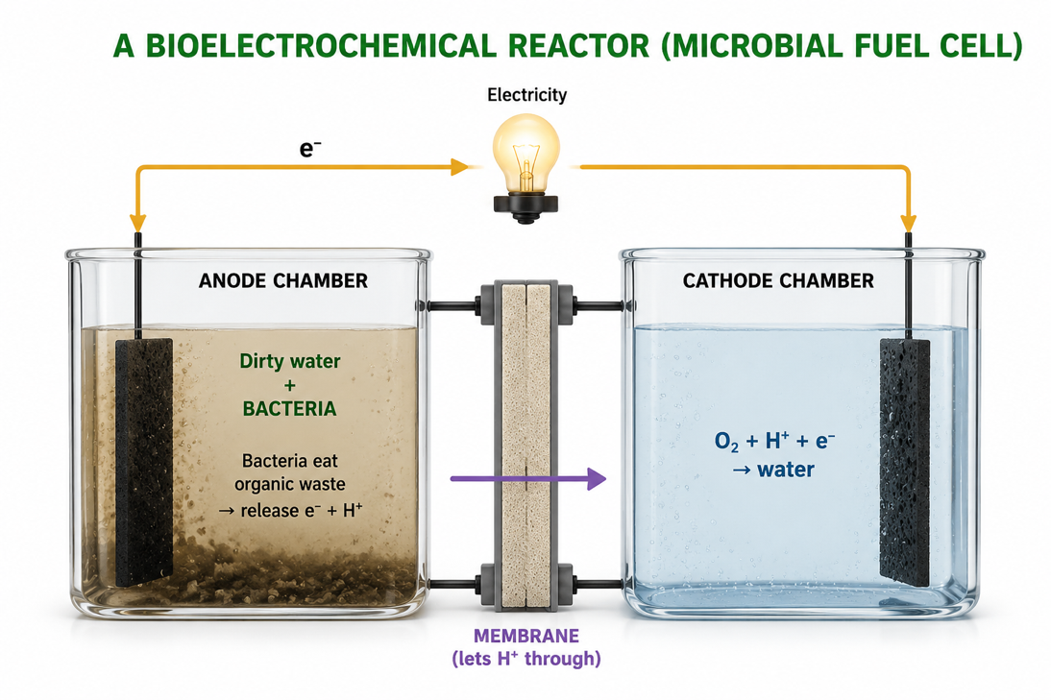
Figure 1: A microbial fuel cell - bacteria digest waste at the anode, releasing electrons that flow through the circuit while H⁺ crosses the membrane.
Terminologies and Concepts
Useful terms for this topic:
- Bioelectrochemical reactor (BER): a device where microbes drive an electric current while treating waste.
- Microbial fuel cell (MFC): a BER that produces electricity from organic matter.
- Electrogenic bacteria: microbes that pass electrons to an electrode.
- Anode chamber: where bacteria break down waste and release electrons.
- Cathode chamber: where oxygen is reduced to water.
- Membrane: separates the chambers but lets H⁺ ions pass through.
- Wastewater treatment: removing pollutants to make water cleaner.
Cleaning Water and Making Power Together
The special value of a bioelectrochemical reactor is that a single process achieves two goals. Dirty water rich in organic pollutants flows into the anode chamber. The bacteria digest those pollutants - the very thing that makes the water dirty - and in doing so they release electrons that become an electric current. The water that leaves is cleaner, and useful electricity (or hydrogen) has been produced. Ordinary sewage treatment uses up energy; a BER can actually produce energy while doing the same job.
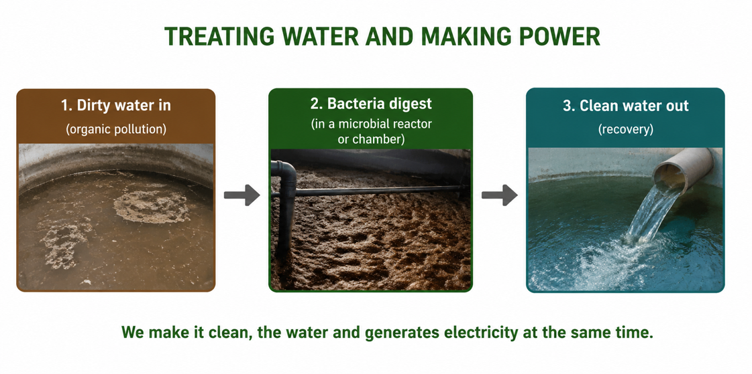
Figure 2: A bioelectrochemical reactor cleans the water and generates electricity in the same process.
Producing Hydrogen (Microbial Electrolysis)
If a small amount of extra voltage is added to the reactor, the bacteria's electrons can be used to make hydrogen gas instead of electricity. This version is called a microbial electrolysis cell (MEC). It offers another way to turn wastewater into a clean fuel - the hydrogen can later be burned or used in a fuel cell, producing only water. This links directly to the earlier lesson on hydrogen as a clean fuel.
Benefits of Bioelectrochemical Reactors
Bioelectrochemical reactors have several important benefits:
- Clean water - they remove organic pollutants from wastewater.
- Electricity - they generate power directly from the waste.
- Hydrogen fuel - with a small voltage boost, they can make clean hydrogen.
- Waste treatment - they can process sewage, farm run-off and food-industry waste.
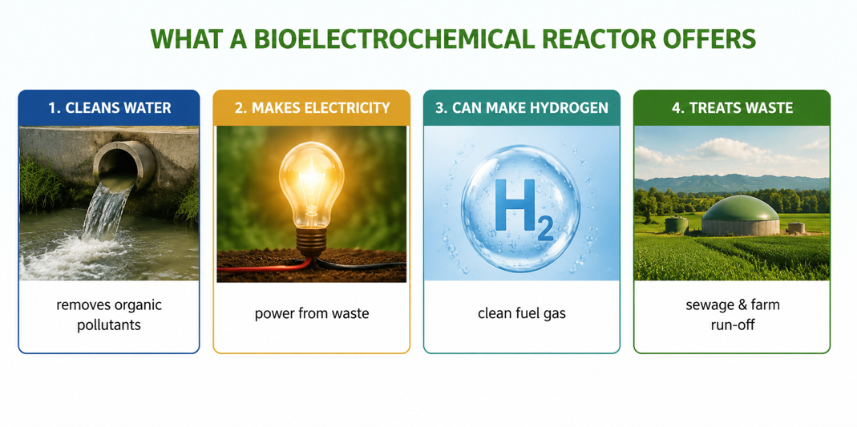
Figure 3: A bioelectrochemical reactor cleans water, makes electricity, can produce hydrogen, and treats waste.
Advantages and Disadvantages
Advantages | Disadvantages
Treats wastewater and makes energy at once | Produces only small amounts of power
Runs on waste - sewage, farm and food waste | Works slowly; needs the right bacteria
Can produce clean hydrogen fuel | Membranes and electrodes can be costly
Reduces pollution and bad smells | Still mostly at the research / pilot stage
Worked Example - Bacteria Releasing Electrons
Electrogenic bacteria oxidise organic matter (shown here as a simple carbon compound) and pass electrons to the anode:
Organic matter + H₂O → CO₂ + H⁺ + e⁻ (at the anode)
The electrons travel through the wire (making electricity), and at the cathode: O₂ + H⁺ + e⁻ → H₂O. As the bacteria keep consuming the organic pollutants, the water becomes cleaner - so one reaction both treats the water and produces power.
Why This Matters
- Water and energy - one device provides clean water and electricity together.
- Pollution - it safely treats sewage and organic waste.
- Clean fuel - it can turn wastewater into hydrogen.
- Sustainability - it turns a waste problem into a useful resource.
PNG Context Example
Many communities in Papua New Guinea lack reliable sewage treatment and electricity, especially in rural and peri-urban areas. A bioelectrochemical reactor is attractive because it could treat wastewater - from households, markets or food processing - while producing a little electricity or hydrogen at the same time, using local bacteria and simple materials. Even at small scale, such reactors could improve sanitation and water quality while providing power for small sensors or lights, addressing two of PNG's biggest development needs at once.
References & Related Documents
Source Documents
- STEM Biology Syllabus - Grade 12. Thema: Energy; Module 12.1 Bioenergy (Bioelectrochemical Reactor / Water Treatment). Department of Education, PNG.
- Biology Standards-Based Syllabus, Grades 11 & 12 (PNG SBC 2020) - Strand 2: Life; examine microbial respiration and the decomposition of organic matter; and human impacts on water quality.
Further Reading & References
- OpenStax Biology - Microbial Metabolism; Decomposition and Nutrient Cycling. https://openstax.org/books/biology
- Khan Academy - Cellular respiration and electron transport. https://www.khanacademy.org/science/biology

